NOC (network on-chip)

General Description
It has the following features:
- Configurable data path widths and address width, at sockets and within the interconnect.
- Configurable, run-time programmable protected regions within the address space.
- Support AXI, AHB and APB protocol interface,etc.

Architecture

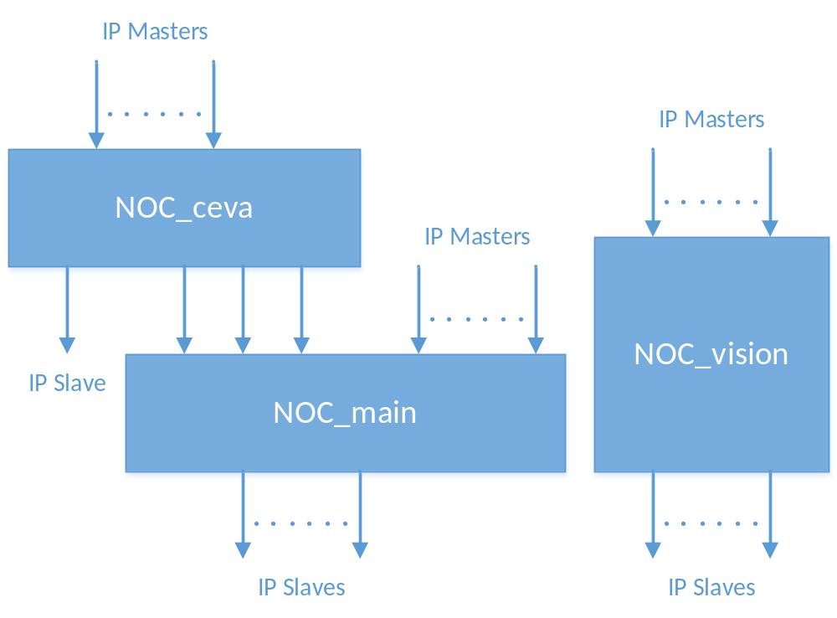
Figure : NOC Architecture

Functional description
A NOC interconnect is built using a socket-based design methodology. It supports industry-standard interfaces to the IP cores that make up an SoC. Cores connect to agents within a NOC interconnect that decouple the functionality of each IP core from the interconnect communications required among the cores, automatically adjusting for mismatches in data width, clock frequency, and protocols. This approach allows core designers to tailor the communications for each core, while still permitting SoC integrators to balance the characteristics of intercore communication paths with respect to metrics such as latency, physical span, clock frequency usage, power domain usage, die area, and power consumption.
The masters connected to NOC_ceva: CEVA.
The slaves connected to NOC_ceva: CEVA, DMA_ceva, MMU_ceva.
The masters connected to NOC_vision: HEVC, H264, JPEG, ISP, Video Interface, Display Control.
The slaves connected to NOC_vision: MMU_isp, MMU_codec.
The masters connected to NOC_main: CCI-400, Coresight, SPI Debug, M7 net, Baseband, DMA_main, eMMC, SPAcc, tRoot, MMU_ceva, USB3.0, Type-c, PCI-e, GMAC.
The slaves connected to NOC_main: CCI-400, Coresight, M7 net, Baseband, DMA_main, eMMC, SPAcc, tRoot, OTP, TRNG/PKA, ARM_A7, ROM, NOC-Secure, Secure, MMU_config, on-chip SRAM, MMU_ddr, CEVA, USB3.0, Video Interface, MIPI, HDMI, Display Control, H264, JPEG, HEVC,ISP, Type-c, PCI-e, GMAC.

